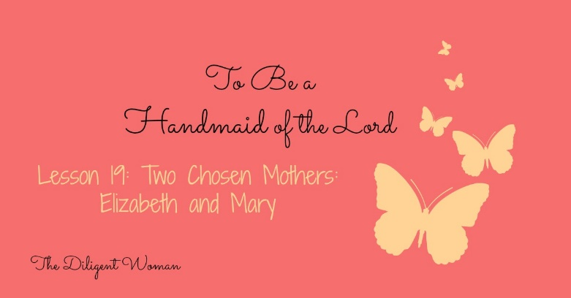
Lesson 19
Two Chosen Mothers – Elizabeth and Mary

Elizabeth
Scripture References – Luke 1:5-25, 36-37, 39-45, 57-80.

1. Who is Elizabeth?

2. How is she described in Luke 1:6-7?

3. Her husband went away to spend his time working in the Temple as a priest, how was he when he came home? (Luke 1:23)

4. How did Elizabeth respond when she realized she was having a baby?

5. What does the angel Gabriel say to Mary about Elizabeth in Luke 1:36-37?

6. Who visited Elizabeth when she was six months pregnant?
7. Tell what happened during this visit.

8. When it was time for Elizabeth to have her baby, how did her neighbors and relatives react?

9. Read Luke 1:59-60. What does Elizabeth’s statement show she understood?

10. Verse 80 says “the child grew and became strong in the spirit,” what part do you think Elizabeth played in this?

Mary
Scripture References – Matthew 1:18-25; 2:11, 13-15, 19-23; 13:55-56; Mark 6:3; Luke 1:26-56: Luke 2; John 19:25; Acts 1:14

11. Write Isaiah 7:14 here.

Read Luke 1:26-56.
12. Who did the angel go to see in Nazareth?

13. How does the angel greet her?
14. What was Mary’s response?

15. What is said of her in verse 30?

16. Can you think of another Bible character of whom something similar is said? (hint, I’m thinking about the book of Genesis. )

17. What is Mary being called to do? (verses 31-33)

18. Mary naturally questions how this will all happen. How does the angel Gabriel reassure her that it is true and possible? (verses 36-37)

19. How does Mary respond when her questions have been answered? (verse 38)

20. How does the Holy Spirit, speaking through Elizabeth, describe Mary? (verses 41-45)

21. Why were these things happening to Mary? (Luke 1:45; Matthew 1:22-23)

23. Luke records for us a song that Mary spoke about these events.
What does Mary tell us in this song? Make a list of things. (i.e. v.48 God noticed her even though she is spiritually unfit for His notice.)

1.
2.
3.
4.
5.
6.
7.
8.
9.
10.

24. Read verse 49, for whom does she say God did these things?

25. Write, in a short paragraph, the story of Jesus’ birth from Luke 2:1-20.

26. Mary was worshipped as well as Jesus after He was born. (Matthew 2:11) TRUE or FALSE

27. How did Mary respond to the visit from the shepherds and the spreading of the news of her Son’s birth? (Luke 2:19)

28. What does the visit to Jerusalem when Jesus is 8 days old tell us about His earthly parents? (Luke 2:22-27, 39)

30. How did Joseph and Mary react to Simeon’s prophecy? (Luke 2:33)

31. Was this life journey going to be an easy one for Mary? (Luke 2:34-35)

32. How did Mary respond to finding Jesus in the Temple after thinking He was lost? (Luke 2:48-50)

33. What did Mary do after the incident in the Temple? (Luke 2:51)

34. Did Mary have any other children? (Matthew 13:55-56)

35. Where was Mary when her Son was on the cross? (John 19:25-27)

36. Where was Mary after Jesus ascended to Heaven? (Acts 1:14)

Conclusion:
These two women are at opposite ends of the stages of the adult time of life: Mary is young and unmarried, while Elizabeth is older, married for many years, and past child bearing. Yet both have their devotion to the Lord noted in Scripture! What worthy examples for each one of us to strive to imitate – no matter which stage of life we are in ourselves. Worshipping God is not a YOUNG thing, nor is it reserved for the OLDER. Living a FULL life in SERVICE to Him is always something we can achieve. We simply have to set our minds to it. Mary and Joseph went to Jerusalem as the customs of the law dictated. This took preparation to pull off. It was not a simple, last minute trip – as is seen when they make the trip when she is 9 months pregnant! Both women were called Blessed because of God’s choosing them for motherhood. They weren’t perfect, just women – but what WONDERFUL WOMEN. I pray that every young lady would strive to be like Mary, and I pray that every woman strives to be like Elizabeth. Don’t dismiss your “timeliness” to serve due to your youth or being older. God has work for ALL of you!

