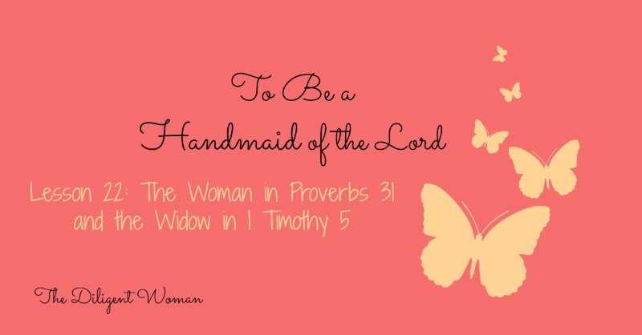
Lesson 22
The Woman in Proverbs 31 and the Widow in 1 Timothy 5

I know you may be wondering just how you are going to learn anything from these two women when you are only a young teenager. You may not be married, but you can still learn from these women. Never underestimate the value of having something for which to STRIVE!

The Virtuous Wife in Proverbs 31:10-31
1. According to Proverbs 31:1, who is telling us about this woman?

2. Write Proverb 31:10 here.

3. What does “virtuous” mean?

4. This woman is a “jack of all trades”, as they say. Make a list of all the things she does.
a.
b.
c.
d.
e.
f.
g.
h.
i.
j.
k.
l.
m.
n.
o.

5. Explain verse 25.

6. Write verse 30 here.

7. Can you think of another verse that compliments Proverbs 31:30?
The Widow in 1 Timothy 5:3-10

8. What does it mean to be a widow who is “really” a widow?

9. Who should be a widow’s first source of comfort and support when she loses her husband?

10. List the qualifications for a widow, who is alone, to be able to be supported financially by the local church. (verses 5, 10)
a.
b.
c.
d.
e.
f.
g.
h.
i.
j.
11. The church can take care of any woman who has ever lost a husband. (verse 9, 11, and 16) TRUE or FALSE

Conclusion:
Well, those are two very serious examples to follow! Did you notice something about both of them? I will give you a hint; it is the SAME thing we noticed about Mary and Martha, Anna, and Elizabeth. These two women are BUSY!
Compare Proverb 31:27 and 1 Timothy 5:13:
(regarding the young widows)
…”they learn to be idle, wandering about from house to house, and not only idle but also gossips and busybodies, saying things which they ought not.”
“She watches over the ways of her household, and does not eat the bread of idleness.”

Proverb 31:27 describes the virtuous woman and the worthy widow! Notice that in 1 Timothy 5 it is the younger widows who have a tendency to misuse their time and talents. This does not mean that an older woman will not become a gossip. It just means that a younger woman is more LIKELY to do so.

So, what CAN you learn for the here and now? The main thing is to realize that these two women didn’t happen overnight! They didn’t say “I do” and become good housekeepers, loving wives, and caretakers of the needy and sick. They were these things, to one degree or another, BEFORE they were “married women”. There are some things that you just can’t do until you are older and married: being a mother and being a wife are the two obvious ones. In your youth you can be a helper of the needy – you just need to look for opportunities. You need to ASK what you can do, where you are needed. Begin by LEARNING how to teach a Bible class. You certainly can’t teach one until you have learned how! Study your Bible to increase your knowledge so that you already have some when it comes time to learn how to share it with others. Learn to cook. You can’t get meals to people who are ill if you can’t make the meal. Start at the beginning and don’t begrudge the journey! The character of these women built reputations that people could count on. You CAN do the same. All you need do is put your focus on WORKING for the Lord, as these women did. Do that and you WILL be a fruitful “worker for the Lord”!

