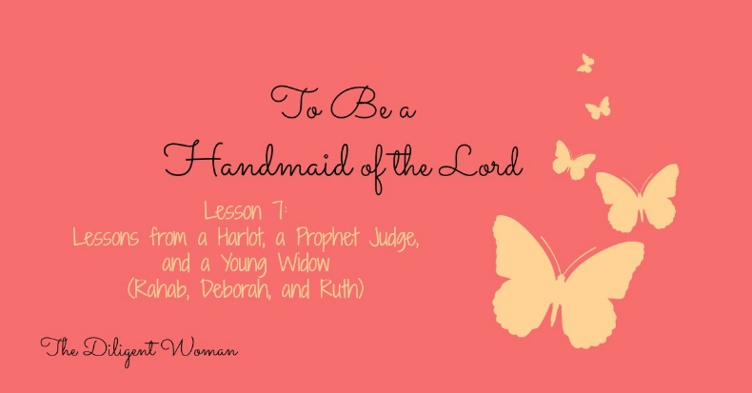
Lesson 7
Lessons from a Harlot, a Prophet Judge, and Young Widow
(Rahab, Deborah, and Ruth)

Scripture References: Joshua 2, 6; Matt.1:5 Heb. 11:31; James 2:25; Judges 4, 5; Book of Ruth
Did you know that the world teaches that God teaches a degrading view of women? You don’t have to look very far to see that many believe that God’s story in the Bible puts women into a subservient position, that it glorifies MAN over WOMAN, and that God wants women to be nothing more than baby machines. If you haven’t noticed it so far in this study, I do believe this is one lesson that can prove that point FALSE! God holds women up – not higher than men, but equal with them. All men AND women in scripture are shown to have faults (excepting Jesus, of course) and strengths – some more than others. “Then Peter opened his mouth and said; ‘In truth I perceive that God shows no partiality’” (Acts 10:34 NKJV). You are your own person with your own mind – do not take my word for it. Read GOD’S WORD and understand what the TRUTH is.
Rahab
Joshua 2, 6; Matthew 1:5; Hebrews 11:31; and James 2:25
1. What did Rahab do for the spies?

2. What did she know (Joshua 2:11)?
3. There was an agreement made that would bring about Rahab’s salvation. What was her part? (Joshua 2:17-20)

4. Why did Rahab “not perish along with those who were disobedient”? (Hebrews 11:31)

Read Joshua 2:21; 6:17, 22-25.
5. In Joshua 6:23, we read Rahab, her father, her mother, and her brothers and all she had was saved. This happened because both parties to the agreement kept their part completely. TRUE or FALSE

6. Would Rahab’s belief that God “is God in heaven above and on earth beneath” have done her any good if she had not followed the spies instructions? (James 2:25-26; Hebrews 11:6)

Deborah
Judges 4 and 5
7. Why did Israel need a judge? (Judges 4:1-3)
8. List the titles we know Deborah wore (Judges 4:4; 5:7)
1.
2.
3.
4.

9. Deborah intended to go out to war herself, just like the male judges before her. (Judges 4:5-7) TRUE or FALSE
10. What prophecy does Deborah make in Judges 4:9?
11. Was Jael’s house on Israel’s side or the King of Canaan’s? (Judges 4:11, 12, 17)

12. How is Jael remembered for what she did? (Judges 5:24-27)

Read Judges 5.
13. Verse 31 says, “let those who love Him be like the rising of the sun in its might”. Who showed their love for the Lord and their brethren?

14. Who did not?

15. Deborah and Barak accepted all the credit for defeating Jabin the King of Canaan. TRUE or FALSE

Ruth
The Book of Ruth
16. Why did Elimilech go to Moab?

17. In a short paragraph, tell the story of Naomi and her family while in Moab.

18. After Naomi decides to return to Bethlehem, what do Orpah and Ruth do?

19. NAMES Research:
Elimelech –
Naomi –
Mahlon –
Chilion –
Orpah –
Ruth –
Boaz –
Obed –

20. What attitude does Ruth show now that she lives in Bethlehem? (Ruth 2:2)

21. Who notices Ruth?

22. What had Boaz heard about Ruth? (Ruth 2:11-12)

Ruth had a REPUTATION! Did it make a difference what that reputation reflected about her? Absolutely!

23. Naomi tells Ruth to put on expensive clothes and makeup to go before Boaz. (Ruth 3:3) TRUE or FALSE
24. Who is Boaz’s mother? (Matt.1:5)

25. Now that Ruth has married Boaz, Naomi must find somewhere else to live in her old age. TRUE or FALSE

26. Fill in the blanks.
Ruth was ________ than _________ sons. (Ruth 4:15)

27. Who is Ruth’s great-grandson? (Ruth 4:17)

Conclusion:
WHAT GLORIOUS WOMEN!
These three women teach us about how obedience is very important to God. Rahab and her family would have been destroyed in Jericho without it. Those who fought to save Israel under Deborah and Barak were commended for it. Ruth would not have been protected if she hadn’t followed Naomi in obeying the laws of Moses.
These women all recognized God’s AUTHORITY and submitted to it. They weren’t made less because of this – they were HONORED and HERALDED through the ages!
Recognize your need like Rahab; be confident in your abilities like Deborah; seize the opportunity like Jael; see God’s hand in your life like Naomi; and live like you appreciate your blessings as Ruth did!

