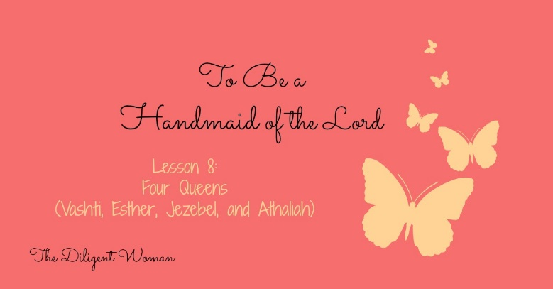
Lesson 8
Four Queens
(Vashti, Esther, Jezebel, and Athaliah)
Scripture References: Book of Esther; 1 Kings 16:31; 1 Kings 18, 19, 21; 1 Kings 22:52; 2 Kings 9; Rev. 2:20; 2 Kings 8:18. 26-27; 2 Kings 11; 2 Chron. 22, 23
Vashti
1. Why did King Ahasuerus give a banquet in the third year of his reign? (Esther 1:3-4)

2. In what condition was the King on the 7th day of his final banquet? (Esther 1:10)

3. What did he ask the eunuchs to do? (Esther 1:10-11)

4. How did Vashti respond? (Esther 1:12)

There are many views about Vashti’s response. One is that the King was asking her to appear ONLY with her crown on, and that this would be degrading and immoral to her. Another is that Persian traditions held that the head Queen would be MORE secluded than any other woman in the court, because of her value and stature. To parade her before others might have been so unheard of and unexpected that she wouldn’t have complied. You can search the internet, bible dictionaries, or almanacs for “Vashti in the book of Esther” and see what they say. But always remember – what MATTERS is what the BIBLE says. If it’s not explained, we don’t need to know, period (Deut. 29:29).
5. How did the King feel about her refusal? (Esther 1:12)

6. The King’s advisors told him what the law was about disobeying the command of the King. (Esther 1:15-20) TRUE or FALSE

7. Instead of following the current law, what did Ahasuerus do? (Esther 1:19-22)
Esther
8. Tell the story of how Esther (Hadassah) comes to be Queen.

9. Some Math!
In what year of the King’s reign did Esther become Queen?

In what year did Vashti fall out of favor?

How many years had the King been without a Queen?

10. In Esther 2:17, what did the King feel/show towards Esther more than towards the other girls?

11. How did others respond to Esther? (Esther 2:8-9, 15)

12. What was Esther’s attitude toward Mordecai? (Esther 2:10, 20)

13. What was Mordecai’s belief about why Esther was chosen as Queen? (Esther 4:14)
14. What is Esther’s first action in dealing with the problem that is brought before her? (Esther 4:16)

For more about Fasting and prayer going together, see Ezra 8:23; Psalm 35:13; Daniel 9:3; Matthew 17:21; Mark 9:29; 1 Corinthians 7:5)
15. What was Esther’s attitude toward the King? (Esther 4:11; 5:1, 4, 8; 7:3, 4; 8:3-6)

Notice how Esther does not change when she’s granted power. She remembers her “place”, aka she remembers the KING’S rightful place, always.

Jezebel
Read Revelation 2:20.
16. If this was the first time you’d heard the name Jezebel, what would you think about it?

Now let’s see what the “original” Jezebel was all about.
17. In 1 Kings 16:31, how does scripture describe Jezebel?

18. How did Obadiah feel about Jezebel? (1 Kings 18:3-4)

19. Who did Jezebel associate with? (1 Kings 18:19)

20. How did Jezebel respond to her prophets being killed? (1 Kings 19:1-3)

21. How did Elijah feel about Jezebel? (1 Kings 19:3, 4)

22. Read 1 Kings 21:5-10. Does Jezebel advise Ahab or take over the problem herself?
23. Is her answer to the problem a just (righteous) one? (see 1 Kings 21:14-16)

24. Is only Jezebel held accountable for what happens to Naboth?
What does this teach you about how God sees things? What about when a friend does something to someone else on your behalf that is not nice? Is the idea of “my hands aren’t dirty so I’m not to blame” a valid one? (See also Matthew 27:19-26)

25. Read 2 Kings 9:30-37. What stands out to you about Jezebel’s behavior?

What is she responding to in this moment?

Athaliah
26. What influence did Athaliah have on Joram, King of Judah? (2 Kings 8:17-18)
27. What is the legacy of the “house of Ahab”? (2 Kings 8:26-27)

27. How did the people feel about Athaliah after her 6 year reign of terror? (2 Kings 11:20)

Notice how little information there is about Jezebel and Athaliah – but really what else do we NEED to know? Read Mark 7:20-23 and see how Jezebel and Athaliah match up to this list! This is where you should see a huge “DANGER THIS WAY” sign! God is about balance – He shows us the right way to be AND He shows us how NOT to be! “Take note, and see what you should do,” (1 Kings 20:22).

Conclusion:
What LEGACY will be remembered because of you and your actions? Doing the right thing at the right time like Esther? Being so vile that other evil people are compared to you, like Jezebel? Or being cut throat enough to kill your own grandchildren like Athaliah?
These women show, above all, how others responded to their behavior. How do others respond to you? What do they think of you? What type of behavior do you encourage in others by your example?
If you’re unhappy with what they see – what are you going to change to make it better?

There is a difference in not being liked for doing what is right, like Jesus (Is. 53:3) and just not being liked or likeable. Pay attention and make the most of the opportunities that you have so you may be improved by the refining that comes from God’s word (Ps. 66:10).

Study Builders
Use this page to note all the verses from the lesson into one or more
of the categories.

In Manner of Life  In Purity | In Word
In Love | In Faith
Additional Notes:

