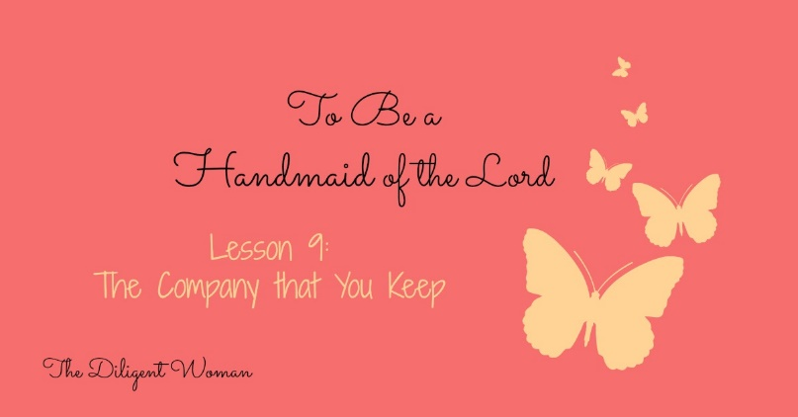
Lesson 9
The Company that You Keep
What is one point that continues to come up in each lesson? That life is all about your CHOICES! The people you choose to be around is very important no matter what stage of life you are in.
Read Psalm 1:1-4
1. List the negative associations mentioned here.
a.
b.
c.
2. List the positives of staying away from these people given in the verses.
a.
b.
c.
d.
3. Read James 1:23-24. Tell me in your own words what these verses are telling us.

There’s a commercial about people who have an illness but they ignore it, hoping it will go away. In the commercial these people are in line at the bank, or the store, and they have a huge snake wrapped around their leg or arm. People around them ask them about it, they say they are just ignoring it or will deal with it later. What do you think the point of the commercial is?

Does forgetting we have a problem make it go away or make it better?

We have to look at these things with a desire and intent (there are those CHOICES again) to correct ourselves so that we’ll be right with God.
4. Read 2 Timothy 2:22. What does God tell us to flee?

5. What does He tell us to pursue?

6. With whom should we pursue them?

See what I mean about God and balance? In ONE verse, He tells us what to avoid, what to seek after, and WHO to spend our time with doing the seeking! Simple!

7. According to Matthew 6:24, which two things can we serve?

8. Can we serve them at the same time?

9. Read 2 Corinthians 6:14-18. What does “unequally yoked” give us a picture of?

10. “Unbelievers” are equated with six things. List them here.
a.
b.
c.
d.
e.
f.

11. Read Proverbs 4:20-27. What is the final choice mentioned in verse 27?

12. Read Proverbs 7:6-7, 24-27. We can always trust that we will be strong enough to avoid falling into sin. TRUE or FALSE

13. Proverbs 1:10-19. This is a vivid description to make a strong point. What is the sin being specifically described? (verse 19)

14. Describe one way you could “deceive” yourself in regards to the friends that you choose (1 Corinthians 15:33-34).

15. Galatians 6:1-2. This verse is easy to fulfill, no matter who my friends might be. TRUE or FALSE

16. What was the reason given for Israel to not marry into the nations around them (Deuteronomy 7:3-4)?
Read 2 Corinthians 10:12, 13
17. What was wrong with those who “commend themselves”?

18. Paul says not to “boast beyond measure”. How do we know where the limits are?

19. To whom or what should we compare ourselves?

20. Read 1 Corinthians 5:11 and 2 Thessalonians 3:14. Can you have an influence on your friends by how you react to their choices?

21. Read Romans 16:17-19. Can people who do not serve Christ have an influence on their friends who do?

22. Read Ephesians 6:10-17

Describe the armor talked about in these verses.

What is the armor to help us do?

Why do you think the helmet is “salvation”?

Why do you think the shield is “faith”?

Why do you think the sword is “the word of God”?

The Lord has provided a way for you to PROTECT yourself against those evil influences Satan will send your way.

Read 1 Peter 5:8-9.

23. The devil really isn’t very interested in you. TRUE or FALSE

24. Are you alone in having to face these battles?
25. Write a prayer asking for God to help you make good choices about the people around you, the places you go, and the things that you do.

Conclusion:

We are in a BATTLE against the vices of Satan and we need help to be STRONG: help from God, help from the Word, and help from others who are going the same way we are going (Matthew 7:13-14).

Choose carefully who you will serve (Joshua 24:15) AND those with whom you will serve!

In Your Bible:
1 Thess. 5:21-22
James 1:2, 3
1 Thess. 5:11
Gal. 6:9
Exodus 23:2

Study Builders
Use this page to note all the verses from the lesson into one or more
of the categories.

In Manner of Life  In Purity | In Word
In Love | In Faith
Additional Notes:

