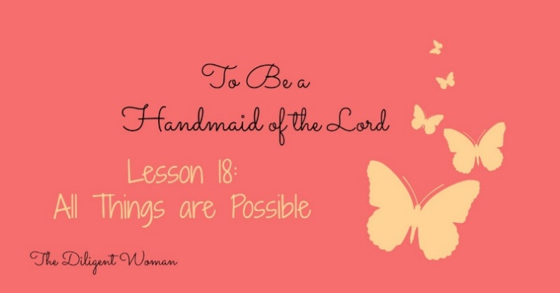
Lesson 18
All Things Are Possible
Real life situation: Someone comes and says “I’ve got a job for you.” Possible responses: “Who am I that you’d ask me to do something that important?” “What if they don’t believe me that my orders are from the boss?” “What if the others won’t listen to me?” “I’m really not very good at that kind of thing.” “Can’t you just send someone else?” (All these were said by Moses in Exodus 3 and 4.)
Are you ever like this? Do you question your ability to do something? How do you respond to new challenges?
What about your dreams? Do you believe they won’t come to be for one reason or another? Do you wish one kind of life for yourself, but expect quite another?
How do you see yourself right NOW? How much do you think you bring to the table of “just getting through” in this life?

Read Jeremiah 29:10-14.
1. What thoughts did God have toward Israel/Judah?

2. What did God promise He would do when they “call upon Me and go and pray to Me”?

Ok, that’s Israel, what about us today?
3. Read Matthew 7:7-8. What is the promise given here?

The apostles believed that Jesus’ teaching made it impossible for people to get to heaven – the rules were just too strict.
4. What was Jesus’ response in Matthew 19:26?

Heaven is a glorious reward! But it takes sacrifice in this life to accomplish God’s will and attain to be there. (Matthew 19:29-30). We can’t hold anything higher than our service to the Lord.
Read Philippians 4:12-13.
5. What are the “all things” that Paul is talking about in verse 13?

Read Matthew 13:31-32.
6. Mustard seed is an herb that grows into a _________.

Read Matthew 17:20
7. How much faith does it take to move mountains?

Read Matthew 21:20-22.
8. What promise is made here and what condition is put upon it?

Read Psalm 34:11-16.
9. What is the way to have “life” and “many days”?
10. In Psalm 34:17-18, does God know about your broken heart?

11. What does God promise in Matthew 6:33-34?

Are you impressed yet? Do you realize that you can do ANYTHING if God is with you? If not, just hold on!

Read Ephesians 3:14-21.
12. What will we be able to comprehend with all the saints? (verse 18)

13. Verse 19 says we will know the love of Christ which __________ ________________.
14. What is left out of verses 20-21 that Jesus can’t do?

15. What works in us?

16. What is that “power” according to Romans 1:16-17?

Read Philippians 1:3-6.
17. Who had begun a “good work” in the brethren in Philippi?

18. Who would finish the work?

19. How can we apply these verses to ourselves individually?

20. What does 2 Timothy 2:15 say we should do as workers for God?

21. What is the promise of Matthew 6:33-34?

Conclusion:
When we talked about serving others we discussed not thinking more highly of ourselves than we ought (Romans 12:3). Humility is a difficult thing to hold on to. The “than you ought” part means there is a level at which you should think of yourself – you just shouldn’t exceed it! We began this study learning just how much God values us. We need to remember that! When you begin to feel down on yourself because things aren’t going the way they should be (or the way you think they should be) – remember that God loves you, holds you up, and will make a way (John 16:27; Psalm 63:8; 1 Cor. 10:13).
He is POWERFUL! He can do all things. He’s promised His help to us. So we should feel empowered to move mountains BY HIS WILL. Recognize your gifts – what you are able to do. Not everyone can do all things well. We’re not meant to! We’re meant to do OUR part, so others can do theirs without needing to fill a gap we’ve left open.
Don’t be like Moses, making excuses and trying to get out of God’s work for Him. Instead, be like Moses, who went forward with God’s help and saved a nation! Don’t reduce God’s creation of you to something worthless by saying you have no part to play. Rather, hold your head high as a child of God, confident that He is standing right beside you, and step into the role that is waiting for you. Imitate Paul and say that whatever comes, you can “do all things through Christ who strengthens me.”

