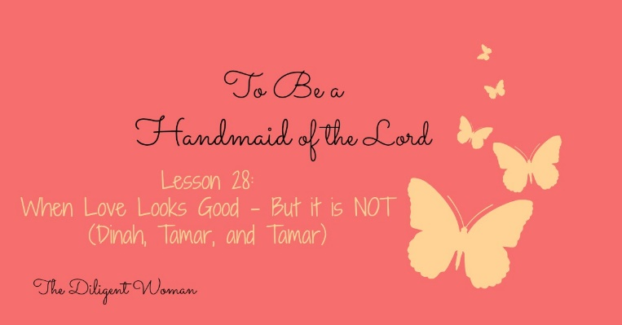
Lesson 28
Dangerous Relationships (Dinah, Tamar, Tamar)
These lessons, I personally believe, are best taught one on one between mother and daughter, especially for this age group. God’s word is always proper and right, but should be considered for the audience (Is. 28:10; 1 Pet. 2:2; Heb. 5:12, 13). I give you this lesson to teach at your discretion. I pray that it may be beneficial.

Scripture References: Gen. 30:21; Gen. 34; Gen. 38; 1 Chron. 2:4; Mt. 1:3; 2 Sam. 13; 1 Chron. 3:9

Dinah
1. Who were Dinah’s parents? (Genesis 30:20, 21; 34:1)

2. Where did Dinah go in Genesis 34:1?

3. Did Dinah’s family see this as something that was all right, they just would have preferred if Shechem had married her first? (Gen. 34:7)

What Shechem did, could not be undone. One lesson that can be learned here is one kind of trouble often leads to another. God set an order to things ‘in the beginning” (Matthew 19:4-6). When we go against that order, it IS going to bring trouble.

Tamar
4. Who was Tamar? (Genesis 38:6)

5. In Genesis 38:14, Tamar took off her _______________ ________________.

6. She put on clothes that made Judah think she was a _______________. (Genesis 38:14-15)

This story shows that clothes identify us to others. Tamar’s choices were deliberate. We must each be deliberate to AVOID what she was seeking to look like. The world likes to tell us that what we wear doesn’t give an invitation to people to stare or think things they shouldn’t be thinking. The world is WRONG. 1 Timothy 2:9 says, “in like manner also, that the women adorn themselves in modest apparel, with propriety and moderation…” If I’m supposed to know what MODEST apparel is, then it follows that I will know what IMMODEST apparel is! The people looking at you must take care of what they look at and what they think – you have to help by not putting a stumbling block in their way (Romans 14:13; Matthew 18:6) as far as it is possible.
Another thing to consider in Tamar’s story – Judah put her into the position to do what she did. God does not show approval of her actions. We are shown that Judah’s not doing what was right regarding the law and his daughter-in-law put her into a position to try to take care of the situation herself. Tamar should have gone to another leader and sought help. Matthew 18:15-18 teaches us that we start with the one who has done wrong toward us, but when no correction is made – bring more people in. In this way, we shine the light of truth on their evil deeds. Tamar had other options, instead she chose to put on the clothes of a harlot and force Judah’s hand. The end result was that, yes, she became a mother, but she also lost any chance at happiness with a husband.
Tamar
7. Who was Tamar? (2 Samuel 13:1; 1 Chron. 3:1-9)

8. How is Jonadab described in 2 Samuel 13:3?

9. What kind of clothes did Tamar have on? (2 Samuel 13:18)

10. What did Absalom do to Amnon because of what Amnon did to Tamar? (2 Samuel 13:32)

This story teaches us that sometimes things happen to us even when we do everything we can to keep it from happening. When people want to do bad things, often they will. Tamar did what she could to make Amnon do what was right. He would not hear her. God’s word in the Old Law would not hold her accountable for this. She did what she could, but unfortunately, she also had to live with the results. When there is sin in the world, we all will suffer because of it. This is what makes us YEARN for HEAVEN. Jesus certainly understands what Tamar went through – He knows all about people choosing to do the wrong things even though you’ve reminded them
of what is right! We need to learn that Jesus can get us through anything (Phil. 4:13). Absalom didn’t do right in murdering his brother, God had laws in place that would have dealt with Amnon – but David didn’t enforce them, and Absalom took matters into his own hands. Once again, we see that one wrong just leads to another wrong.

So, pay attention to your surroundings.
Be careful of the friends you choose – are they going to lead you to do what is right?
You do the best that you can do, and let God take care of the rest.
We all are going to sin (Romans 3:23), but the Lord will forgive if we repent and obey His word.

Read Psalm 51:10-11

It is said that this Psalm was written by David after he realized all of his sins in taking Bathsheba for his own. What does he ask the Lord to do in verse 10?

David had sinned, would God have been right to turn away from David?

Instead, David asks what in verse 11?

Write a prayer that asks God to help you be pure in heart.

